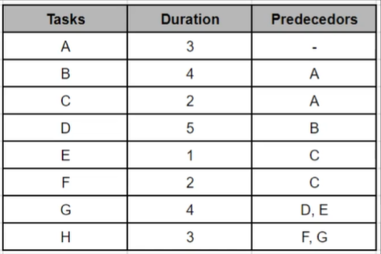

**Delivery date: After 19 days.**

**Tasks which can be delayed: C, E & F**